GOVT. MEERA GIRLS COLLEGE UDAIPUR (RAJ.)
UDYAN VIKAS AND HARIT PARISAR COMMITTEE
SESSION 2023-24
REPORT
The term, “Go Green “has become a popular term in the today’s world. Green and clean environment is very beneficial and attract everyone and gives suitable environment for work.
Keeping this in mind Udyan Vikas and Harit Parisar Committee keep the college campus clean, green and beautiful throughout the academic session.
Many programs were organised by the committee throughout the 2023-24 session.
Plantation programs like plantation, cleanliness and celebration of “ Rohida ,The State Flower of Rajasthan Utsav” were organised under the guidance of Committee in-charge Dr. Savita Chahar and committee members Dr.Saroj Gupta Dr. Manisha Choubisa, and Dr. Nasreen Banu.
A plantation program was organised by committee on 17.07.2023. In this program legendary plants of “Seeta Asoka” ( Saraca asoca) were planted in college campus with the help of students, Dr. Meena Baya, Principal ,Committee members and faculty members planted these plants .
In the month of March 2024,flowers on Rohida tree ( State flower of Rajasthan ) were bloomed for the first time and for this achievement, “Rohida Tree week” was organised in the month of March, 2024 by the committee with collaboration of Botany department to create awareness in students regarding the state flower plant of Rajasthan.
During Session 2023-24 various medicinal, ornamental and fruit plants such as Awla, Arjun, Chikoo, Shahtoot, Sheesham, Chandani, Sarpgandha, rose, China rose, hybrid varieties of pomegranate were planted in the College Campus.Students and faculty members took part in these program with enthusiasm.
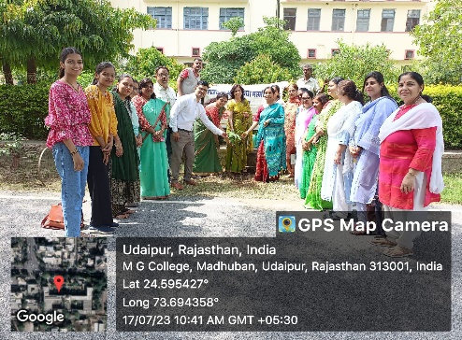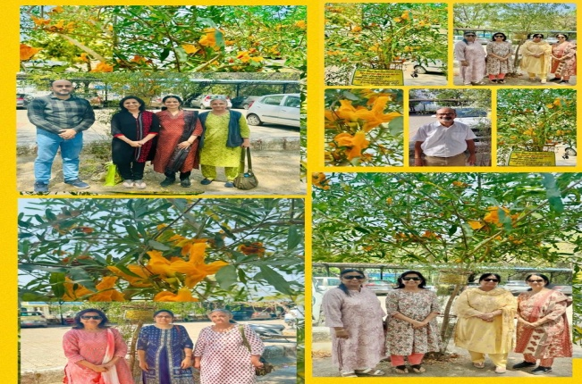
July 2023, Plantation of Seeta AshokPAGE 1 March 2024, Celebration Of Rohida Tree Week

DR. SAVITA CHAHAR

Convener,
Udyaan Vikas and Harit Parisar Committee

