GOVT. MEERA GIRLS’ COLLEGE UDAIPUR (RAJ.)
UDYAN VIKAS, HARIT PARISAR AND BEAUTIFICATION COMMITTEE
SESSION 2024-25
REPORT
The term, “Go Green “has become a popular term in the today’s world. Green and clean environment is very beneficial, attracts everyone and gives suitable environment for work.
Keeping this in mind UdyanVikas, HaritParisar and Beautification Committee keeps the college campus clean, green and beautiful throughout the academic session.
Many programs were organised by the committee throughout the 2024-25session.
On 30th August, 2024, “MEERA FRUIT ORCHARD’, was created in college premises near Botanical garden. Prof. Deepak Maheshwari, Principal, Government Meera Girls’ College Udaipur Raj. And Dr. Savita Chahar, convener Udyan Committee inaugurated this garden by planting hybrid variety of Apple plants. After this various fruit plants like Cherry, Orange, Ilaayachi Banana were planted by committee members Dr. Sofia Husain, Dr. Mnisha Caubisa, Dr. Nasreen Banu and Rehana Parveen and students of different streams.
A plantationprogram was organised under the guidance of Committee in-charge Dr. Savita Chahar and committee members Dr. Sofia Hussain, Dr. Manisha Choubisa, Dr. Nasreen Banu and Dr. Rehana Parveen on 18th and 23rdSeptember, 2024 different species of medicinal plants, fruit plants and different types of succulent plants were planted by faculty members and students
In the month of March 2025, flowers on Rohida tree (State flower of Rajasthan) were bloomed, for this achievement, “RohidaTree week” was organised in the month of March, 2025 by the committee with collaboration of Botany department to create awareness in students regarding the state flower plant of Rajasthan. On 20th April, 2025, eco-friendly earthen pots were hanged in College campus to provide water for birds during summer season in collaboration with Innocent street friend society.
During Session 2024-25 various medicinal, ornamental and fruit plants such as Aonla, Arjun, Chikoo, Shahtoot, Sheesham, Chandani, Sarpgandha, rose, China rose, hybrid varieties of pomegranate were planted in the College Campus.Students and faculty members took part in theseprogramwith enthusiasm

DR. SAVITA CHAHAR
Convener,
Udyaan Vikas, Harit Parisar and Beautification committee

page -1

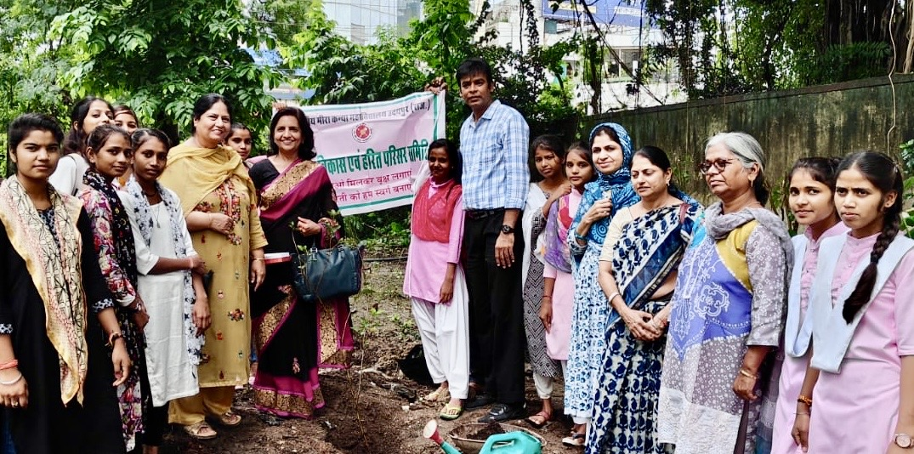
Meera Fruit Orchard- 30.08.2024
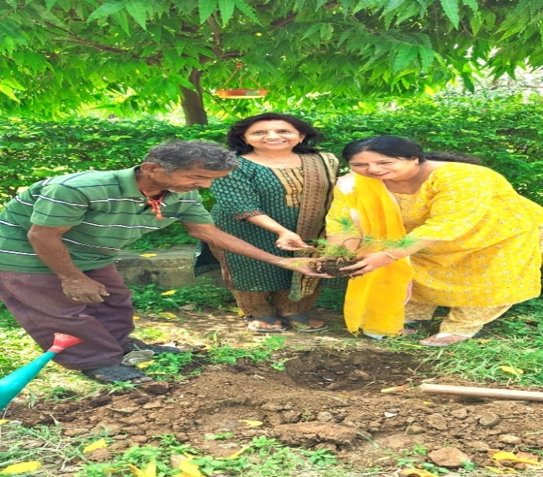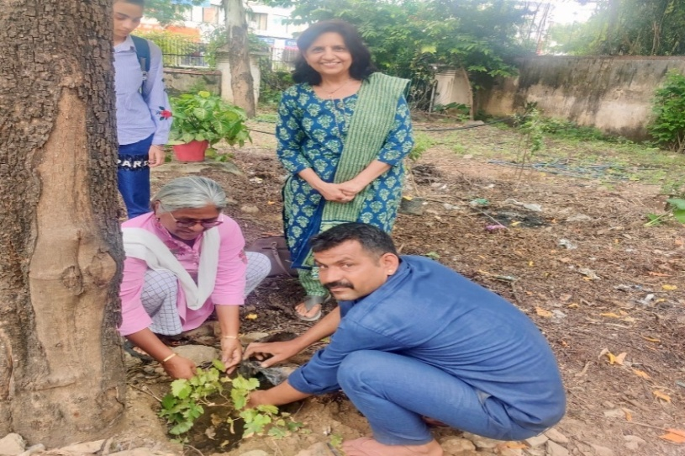
18.09.2024 and 23.09.2024 Plantation Programme
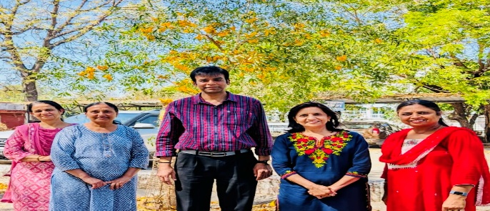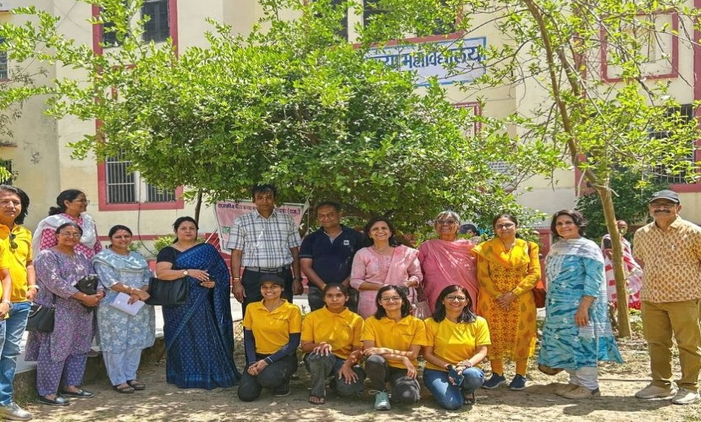
Blooming of ROHIDA TREE (Rajasthan State Flower) March 2025 Hanging of earthen pots for birds 20.04.2025

page -2

