GOVT. MEERA GIRLS’ COLLEGE UDAIPUR (RAJ.)
UDYAN VIKAS, HARIT PARISAR AND BEAUTIFICATION COMMITTEE
SESSION 2025-26
REPORT
The term, “Go Green “has become a popular term in the today’s world. Green and clean environment is very beneficial, attracts everyone and gives suitable environment for work.
Keeping this in mind Udyan Vikas, Harit Parisar and Beautification Committee keeps the college campus clean, green and beautiful throughout the academic session.
Many programs were organised by the committee throughout the 2024-25session.
On 29th July 2025, “The Dragon Fruit Orchard’ was created in Meera Vatika near Panna Dhay Hall. Prof. Deepak Maheshwari, Principal, Government Meera Girls’ College Udaipur Raj. And Dr. Savita Chahar, convener Udyan Committee inaugurated this garden by planting Dragon fuits plants. After this many Dragon fruit plants were planted by committee members Dr. Sofia Husain, Dr. Mnisha Caubisa, Dr. Vartika Jain, Dr. Anju Beniwal and students of different streams.
A plantation program was organised under the guidance of Committee in-charge Dr. Savita Chahar and committee members Dr. Sofia Hussain, Dr. Manisha Choubisa, Dr. Vartika Jain and Dr. Anju Beniwal on 1st August 2025. Hybrid varieties of pomegranate and different species of medicinal plants, fruit plants and different types of succulent plants were planted in the college premise.
A Cleanliness program was organised by committee on 16th December2025. Students and faculty members took part in this program with enthusiasm.

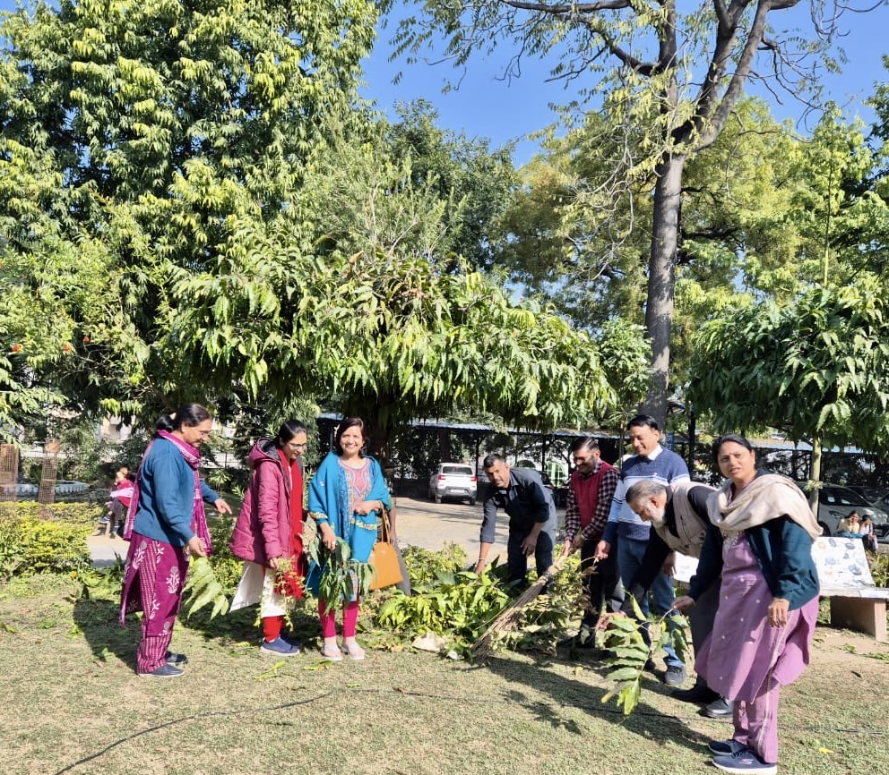
Page 1
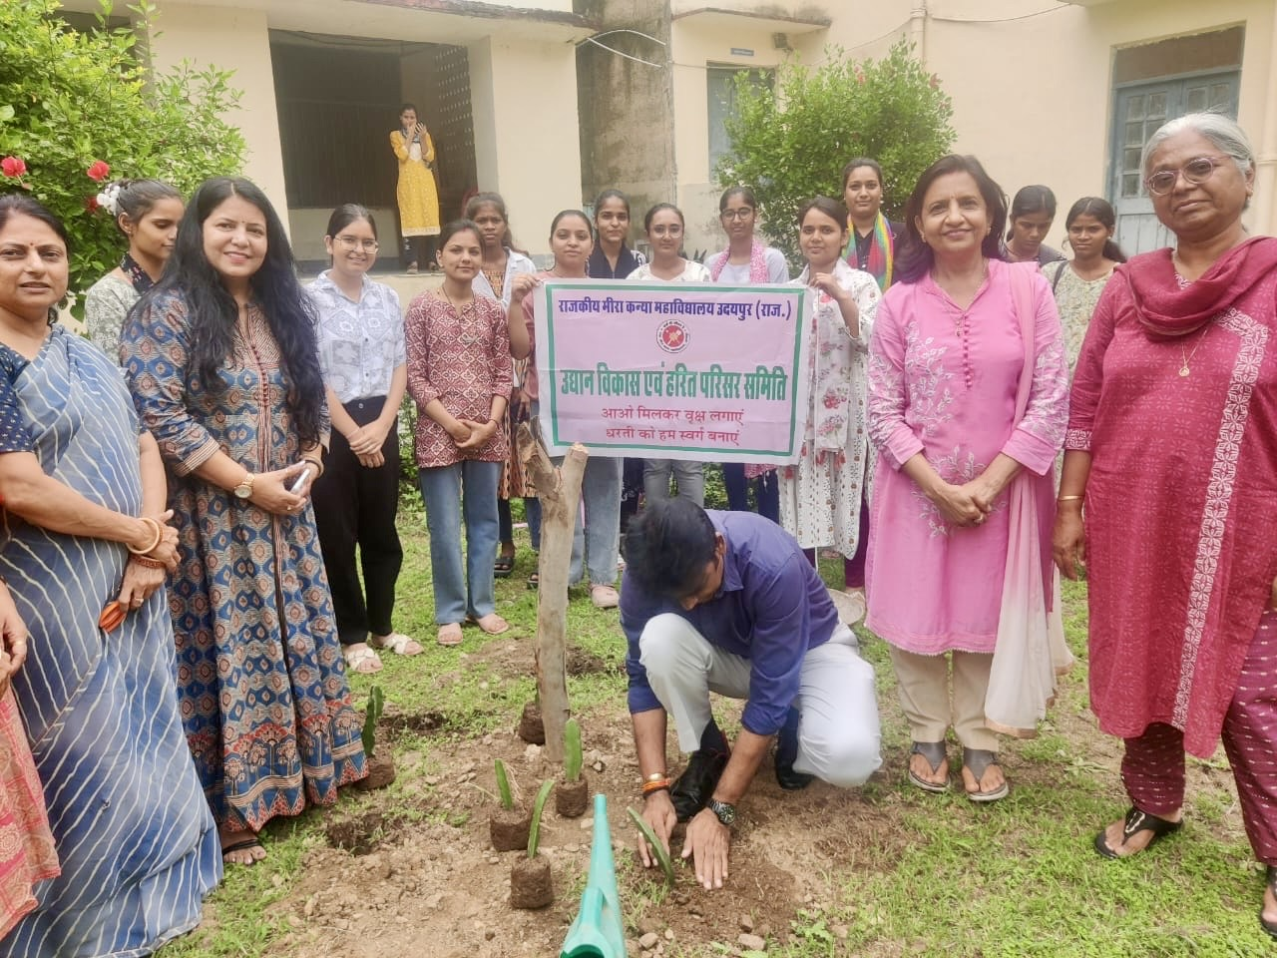
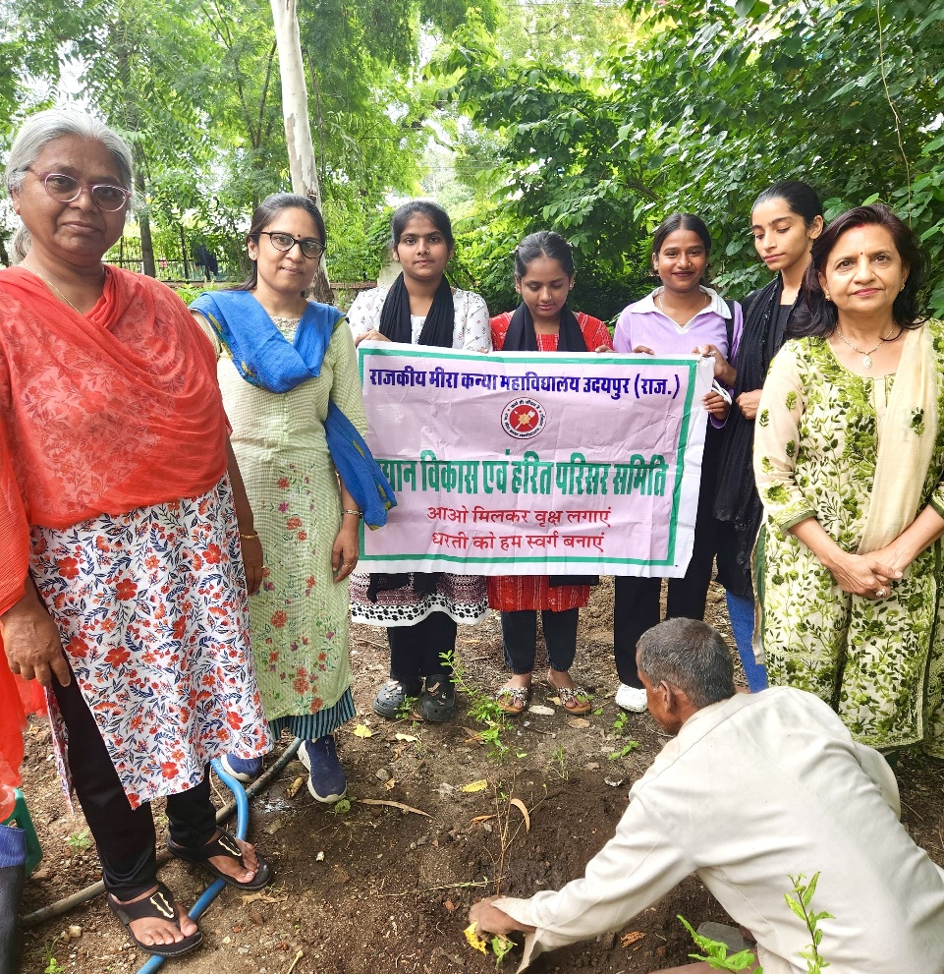

DR. SAVITA CHAHAR
CONVENER

Page 2

